Technical description of transparent bioreactor

The transparent bioreactor is composed of a removable transparent slide (e.g. round glass cover slip in the configuration described in this technical report) and a set of modular PDMS components that can be assembled in two different configurations:

* **TB**: one flow circuit (i.e. single inlet-single outlet)
* **LiveBox1**: two flow circuits (i.e. two inlets-two outlets) separated by a membrane, allowing for air-liquid (ALI) or liquid-liquid interface (LLI) cultures or perfusion of 3D cellular constructs

These configurations will be analyzed in details in following paragraphs.

# TB

This configuration requires three PDMS cylindrical components:

* **Bottom housing** (Fig. A-1), which is characterized by a round window onto the bottom surface and a cylindrical slot for the glass disc (Fig. A-2)
* **Inner cylinder** (Fig. A-3), i.e. an open cylinder that fits with the slot of the bottom housing, holding the glass disc
* **Top** (Fig. A-4), i.e. the Multi Compartmental modular Bioreactor (MCmB) top

The first step in assembling the system is to place the glass disc onto the base of the bottom housing. Then the inner cylinder has to be inserted inside the bottom housing slot and pressed downward to held the glass disc in place. The so assembled bottom part of the TB bioreactor is stable and watertight without the need of an external clamp system. Then the top component closes the bioreactor chamber, fitting with a male-female joint on the bottom part and providing the flow inlet and outlet for subsequent dynamic cultures. The system is designed to reproduce the typical volume of a 24 well plate, allowing for the use of most of the standard culture protocols, avoiding any scaling or modification.

A typical 2D dynamic culture using TB can be carried out following the consecutive steps summarized below:

1. Assemble the bottom part of the TB and then sterilize it. The system is compatible with the common sterilization methods;
2. Seed cells onto the glass disc housed in the bottom part, following the standard protocols.;
3. Close the system using the sterilized top part and place the bioreactor (Fig. A-5) inside an incubator until reaching proper cells adhesion;
4. Start the dynamic culture, connecting the inlet and the outlet of the bioreactor to a fluidic circuit filled with the desired culture medium.

In case of a 3D culture, the construct can be placed directly on the glass disc housed in the bottom part.

In both cases the removable transparent glass bottom allows for:

* **Live imaging** during static/dynamic culture, i.e. in situ imaging of the three-dimensional culture environment using microscopy techniques. The visualization of cell response to their environment, in real time, helps to further elucidate the influences of culture parameters (e.g. flow induced shear stress) as well as scaffold architecture and its surface features (if present) on cell response and growth of new tissue(s).
* **Post culture imaging** (eventually including staining procedures) or any other sample processing. After disassembling the TB, the glass slide supporting the cultivated cell monolayer or 3D construct can be easily removed from its bottom part and used for further investigations and analysis.

# LiveBox1

This configuration requires four PDMS components:

* **Bottom housing** (Fig. B-1) which is characterized by a round window onto the bottom surface and a cylindrical slot for the glass disc (Fig. B-2). Two grooves are realized in opponent positions to house the inlet and outlet tubes of the lower perfusion circuit
* **Lower inner cylinder** (Fig. B-3) that fits with the slot of the bottom housing holding the glass disc, and provides both the inlet and outlet tubes for the lower perfusion circuit and the membrane (Fig. B-4) basement, if present
* **Upper inner cylinder** (Fig. B-5) that fits with the lower inner cylinder holding the membrane
* **Top** (Fig. B-6), i.e. the Multi Compartmental modular Bioreactor (MCmB) top

As described in the TB configuration, the first step in assembling the system is to place the glass disc onto the base of the bottom housing. The lower inner cylinder has to be inserted inside the slot of the bottom housing, paying attention to align the tubes with the groves of the latter, and pressed downward to held the glass disc in place. If required, a porous membrane can be placed inside the slot realized onto the top of the lower inner cylinder. Then the upper inner cylinder has to be fitted into the slot to hold the membrane in place. As claimed in the TB paragraph, the so assembled bottom part of the LiveBox1 is stable and watertight without the need of an external clamp system. Then the top component closes the bioreactor chamber, fitting with a male-female joint on the bottom part and providing the flow inlet and outlet for subsequent dynamic cultures. The system is designed to reproduce the typical surface of a 12 well plate transwell insert, allowing for the use of most of the standard protocols for culture on interfaces, avoiding any scaling or modification.

Moreover the LiveBox1 can be equipped with embedded or removable sensors/actuators thanks to its modularity. For example, electrodes for trans epithelial electrical resistance (TEER) measurements can be placed into the bioreactor culture chamber (above and below the membrane), passing through the non conductive PDMS components.

Dynamic 2D cultures using LiveBox1 can be carried out following the consecutive steps as reported below:

1. Assemble the bottom housing, the glass disc and the inner lower cylinder of the LiveBox1.
2. To perform conventional 2D cells culture on glass disc place the upper inner cylinder and sterilize the system. Seed cells onto the housed glass disc, following the standard protocols and go to point 5. Otherwise skip this point
3. To perform interface cultures on the bioreactor membrane, place the porous support into the slot of the lower inner cylinder, then clamp it with the upper inner cylinder and sterilize the system. Seed cells onto the bioreactor membrane, following the standard protocols and go to point 5. Otherwise skip this point
4. To culture cells on both glass disc and porous membrane sterilize the system. Seed the cells onto the glass slide. Place the sterilized membrane and hold it with the sterilized inner upper cylinder. Seed the cells onto the porous surface, following the standard protocols.
5. Close the chamber with the sterilized top
6. Connect the inlets and the outlets of the bioreactor (Fig. B-7) to the fluidic circuit(s) filled the desired culture media, in order to assure at least one inlet and one outlet for the dynamic culture

In case of a 3D culture, the construct can be placed directly on the glass disc housed in the bottom part or onto the membrane used as support. Dynamic 3D cultures can be performed following the steps summarized above, removing the membrane if not needed.

The removable transparent glass and membrane allow for:

* **Live imaging** during static/dynamic culture, i.e. in situ imaging of the three-dimensional culture environment using microscopy techniques. The visualization of cell response to their environment, in real time, helps to further elucidate the influences of culture parameters (e.g. flow induced shear stress) as well as scaffold architecture and its surface features (if present) on cell response and growth of new tissue(s).
* **Live imaging** during static/dynamic culture **onto the membrane surface**, using a long working distance objective.
* **Post culture imaging** (eventually including staining procedures) or any other sample processing. After disassembling the LiveBox1, the glass slide or the membrane supporting the cultivated cell monolayer or 3D construct can be easily removed from their slots and used for further investigations and analysis.

**Figure A - TB configuration**

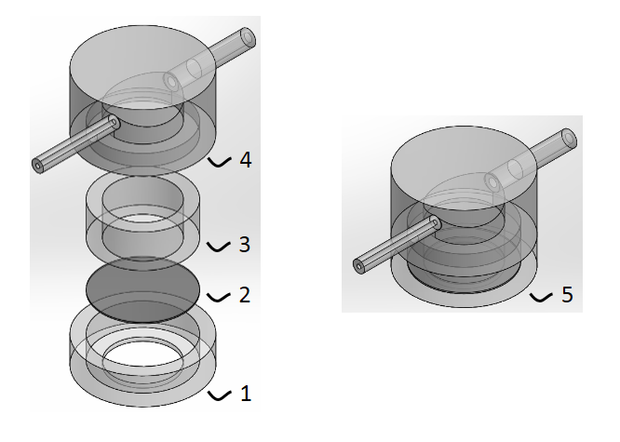

**Figure B – LiveBox1 configuration**

